Test Description:

Test Login In feature + "עדיין לא רשום" feature
Test Purpose: Verify that Login feature work for account after confirming validation email in Sign Up process
Test Run Instructions: <Describe any special instructions needed to execute this test>
Test Run Information:  Tester Name: Ariel  Date of Test: 12/10/2023 | Prerequisites for this test: None
Software Versions:
Application:
Browser: Chrome
Operating System: Win 10 Pro
Required Configuration:
Sign Up user, after Email validation

User Email : arieldanino98@gmail.com
Password : a123456

NOTES and RESULTS:

TEST SCRIPT STEPS/RESULTS
STEP | TEST STEP/INPUT | EXPECTED RESULTS | ACTUAL RESULTS |  | PASS/FAIL
Sanity – Functionality Positive – Log in – התחברות
 | Be on page  https://my.issta.co.il/login | Login Page opens | Login Page opens |  | PASS
 | Enter email "כתובת דוא"ל" such as  arieldanino98@gmail.com | No error pop ups | No error pop ups |  | PASS
 | Enter Password "סיסמא" such as "a123456" | No error pop ups | No error pop ups |  | PASS
 | Click on Log in "התחברות" | Navigate to site with user details | Navigate to site with user details |  | PASS
 |  | Sanity – GUI Testing – Log in– התחברות
1 | Verify grayed text in "כתובת דוא"ל" field | "כתובת דוא"ל" | 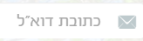 |  | PASS
2 | Click on field כתובת דוא"ל"" | Grayed text is minimized |  |  | PASS
3 | Verify grayed text in הזנת סיסמה" " field | "הזנת סיסמא" | 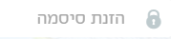 |  | PASS
4 | Click on field הזנת סיסמה" " | Grayed text is minimized |  |  | PASS
5 | Verify that Login Button is align with  Email field  Password field | Align with Email and Password fields | Align with Email and Password fields  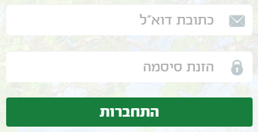 |  | PASS
6 | Verify Colors of Log In Button are as the website theme | Verified | Verified |  | PASS
7 | Verify no spelling errors in Log In button "התחברות" | "התחברות" | "התחברות" |  | PASS
8 | Verify picture that describe each field uploads correctly | Expected pictures in email field and Password field: |  |  | PASS
9 | Verify text beneath התחברות | צוות המומחים של איסתא כאן עבורכם, בכל שאלה או פניה  ניתן לפנות למוקד השירות בטלפון  03-7777070  בימים א' - ה' בשעות 17:00–10:00 | 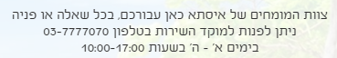 |  | PASS
 |  | Sanity – Functionality Positive – "עדיין לא רשום"
1 | Be on page  https://my.issta.co.il/login | Login Page opens | Login Page opens |  | PASS
2 | Click on "עדיין לא רשום"  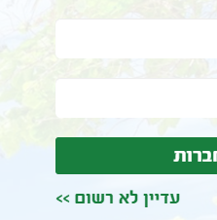 | Navigates to sign up page  https://my.issta.co.il/signup | Navigates to sign up page  https://my.issta.co.il/signup |  | PASS
 |  | Sanity – GUI Testing- "עדיין לא רשום"
1 | Verify "עדיין לא רשום" is align with all other buttons and fields | Align | Align  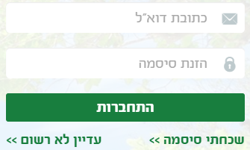 |  | PASS
Sanity – Security testing
1 | Enter input in password | Password is hidden | 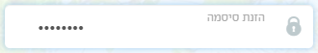 |  | PASS
2 | Verify password is hidden in devltools when clicking ""התחברות | Password is hidden | Password is not hidden, user account details are visible |  | FAIL
Sanity - Localization
1 | Verify no spelling errors in Sign In Page, Button | Verified | Verified |  | PASS

Test Description:

Challenge the Log In Feature
Test Purpose: Verify that Login feature won't work for account not completing validation email in Sign Up process +
Log in won't allow user to continue with blank input/half input
Log in won't work if he enters past passwords after changing
Test Run Instructions: <Describe any special instructions needed to execute this test>
Test Run Information:  Tester Name: Ariel  Date of Test: 12/10/2023 | Prerequisites for this test: None
Software Versions:
Application:
Browser: Chrome
Operating System: Win 10 Pro
 | Required Configuration: none
NOTES and RESULTS:

TEST SCRIPT STEPS/RESULTS
STEP | TEST STEP/INPUT | EXPECTED RESULTS | ACTUAL RESULTS |  | PASS/FAIL
Sanity – Functionality Negative – Log In – התחברות
 | Go to Sign Up page:  https://my.issta.co.il/signup | Sign up page opens | Sign up page opens |  | PASS
 | Enter First Name "שם פרטי" such as "נסיון" | No error pop up  Input inserted | No error pop up  Input inserted |  | PASS
 | Enter Last Name "שם משפחה" such as "נסיון" | No error pop up  Input inserted | No error pop up  Input inserted |  | PASS
 | Enter Email such as:  gicixew785@eazenity.com | No error pop up  Input inserted | No error pop up  Input inserted |  | PASS
 | Enter phone number "טלפון נייד" such as  "052-2788077" | No error pop up  Input inserted | No error pop up  Input inserted |  | PASS
 | Enter ID "תעודת זהות" such as "206409138" | No error pop up  Input inserted | No error pop up  Input inserted |  | PASS
 | Enter Password "סיסמא" such as "a123456" | No error pop up  Input inserted | No error pop up  Input inserted |  | PASS
 | Enter Same password in Verify Password "אימות סיסמא" " a123456" | No error pop up  Input inserted | No error pop up  Input inserted |  | PASS
 | Click on "הרשמה" | Page reload confirming Sign up Info   |  |  | PASS
 | Don’t open email validation and don't click on validate Sign up link. | Not validated | Not validated |  | PASS
 | Go to Login Page:  https://my.issta.co.il/login | Login page opens | Login page opens |  | PASS
 | Enter Email " gicixew785@eazenity.com" | Entered | Entered |  | PASS
 | Enter Password: a123456 | Entered | Entered |  | PASS
 | Click on "התחברות" | Error message beneath "התחברות" button  תהליך ההתחברות נכשל נסה שנית  User is not able to advance | Error message beneath "התחברות" button  תהליך ההתחברות נכשל נסה שנית  User is not able to advance  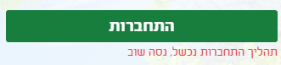 |  | PASS
 |  | Sanity – Error handling – התחברות
1 | Be on Login Page  https://my.issta.co.il/login | Login page opens | Login page opens |  | PASS
2 | Enter validated Email  Arieldanino98@gmail.com | Input inserted | Input inserted |  | PASS
3 | Leave password empty | No error popup | No error popup |  | PASS
4 | Click on Log in | Error message beneath Password field  הזנת סיסמא הינה חובה . User can't process into site | 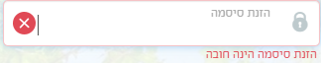 |  | PASS
5 | Be on Login Page  https://my.issta.co.il/login | Login page opens | Login page opens |  | PASS
6 | Leave Email field as blank | No error popup | No error popup |  | PASS
7 | Enter valid password for existing account  "a123456" | No error popup  Input inserted | No error popup  Input inserted |  | PASS
8 | Click on Login "התחברות" | Error popup message beneath Email field  "כתובת דוא"ל הינו שדה חובה"  User can't process into site | 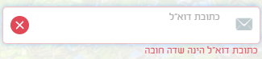 |  | PASS
9 | Be on Login Page  https://my.issta.co.il/login | Login page opens | Login page opens |  | PASS
10 | Leave both Email "כתובת דוא"ל" and Password "סיסמא" blank | No error pop ups | No error pop ups |  | PASS
11 | Click on Log In | Both fields light up with error messages and user can't proceed to site | Both fields light up with error messages  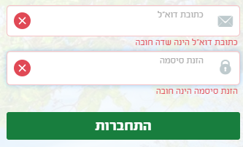 |  | PASS
 |  | Sanity – Functionality Negative – -התחברות – password change
1 | Be on Login page  https://my.issta.co.il/login  after changing password from  a123456  to: a1234567 | Page opens | Page opens |  | PASS
2 | Enter validated email into "כתובת דוא"ל"  Arieldanino98@gmail.com | No error pop ups  Input inserted | No error pop ups  Input inserted |  | PASS
3 | Enter past password  a123456 | No error pop ups  Input inserted | No error pop ups  Input inserted |  | PASS
4 | Click on "התחברות" | Error message beneath "התחברות"  "תהליך התחברות נכשל, נסה שנית" | Error message beneath "התחברות"  "תהליך התחברות נכשל, נסה שנית" |  | PASS
 |  | Sanity – GUI Testing – התחברות
1 | Be on Login Page:  https://my.issta.co.il/login | Login page opens | Login page opens |  | PASS
2 | Verify "איסתא " logo | Issta Logo appears top of page |  |  | PASS
3 | Verify text appears on bottom of fields | "צוות המומחים של איסתא כאן עבורכם בכל שאלה או פניה ניתן לפנות למוקד השירות בטלפון 03-7777070  בימים א' – ה' בשעות 10:00-17:00 | 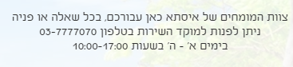 |  | PASS
4 | Verify "כתובת דוא"ל" field appears with grayed text | "כתובת דוא"ל" appears in field as first text and is grayed |  |  | PASS
5 | Verify "הזנת סיסמה" field appears with grayed text | "הזנת סיסמה" appears in field as first text and is grayed | 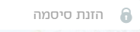 |  | PASS
6 | Verify pictures shown in correct fields | pictures shown in correct fields | pictures shown in correct fields  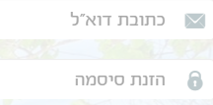 |  | PASS
7 | Click on "כתובת דוא"ל" field | Grayed text minimizes |  |  | PASS
8 | Click on "הזנת סיסמה" field | Grayed text minimizes |  |  | PASS
9 | Leave all fields blank | No error pop ups | No error pop ups |  | PASS
10 | Click on Log In | Error pictures pop up  On each field left blank | On each field left blank |  | PASS
11 | Verifty error pictures are align with one another | Align |  |  | PASS
12 | Be on Login Page  https://my.issta.co.il/login | Login page opens | Login page opens |  | PASS
13 | Enter validated Email  Arieldanino98@gmail.com | Input inserted | Input inserted |  | PASS
14 | Leave password empty | No error popup  Input inserted | No error popup  Input inserted |  | PASS
15 | Click on Log in | Red Error message beneath Password field  הזנת סיסמא הינה חובה .  Field is highlighted in red  Error picture appears |  |  | PASS
16 | Be on Login Page  https://my.issta.co.il/login | Login page opens | Login page opens |  | PASS
17 | Leave Email field as blank | No error popup | No error popup |  | PASS
18 | Enter valid password for existing account  "a123456" | No error popup  Input inserted | No error popup  Input inserted |  | PASS
19 | Click on Login "התחברות" | Red Error message beneath Password field  הזנת סיסמא הינה חובה .  Field is highlighted in red  Error picture appears |  |  | PASS

